Module Code | IY453
Group | B
Module Title | Software Design and Implementation
Assessment Type | Coursework Stage 4
Module Tutor Name | Jonathan Shore
Student ID Number | P486024
Date of Submission | 6/4/2026

I confirm that this assignment is my own work. Where I have referred to academic sources, I have provided in-text citations and included the sources in the final reference list.

Where I have used AI, I have cited and referenced appropriately.

Table of contents:
Introduction:………………………………………………………………………………………….2
Analysis and design:……………………………………………..……………………………..…..2
Testing:……………………………………………………………………………………………...12
Technical Elements:……………………………………………………………………………….16
Evaluation:…………………………………………………….……………………………………18
References:…………………………………….…………………………………………………..20
Appendix Code Listing:…………………………………………………………………………...20

Introduction:
The program's purpose is to design a text-based adventure game that allows players to interact more by relocating them to a fictional world where they can solve problems and make decisions. This game relies on descriptive writing and user input.
This game has functional and non-functional requirements. The functional requirements are like player interaction, engagement, and error handling. The non-functional requirements of the game are like code quality, user experience, testing, debugging, and documentation.
The game uses at least 30 binary choices in each scenario to meet the functional requirements. Some choices lead to a "Game Over" state, while others allow progress. Additionally, the game must provide clear feedback on its choices.
Additionally, I am implementing that program by creating its algorithm, which is a class diagram, first to know what we need to do in implementing the program code to make it work efficiently. Therefore, the Algorithm and the class diagram are important to give me an idea of what I need to do to implement the program, and I am doing them to help myself in creating the program code, which is the way of implementing them in the program code.

Analysis and design:

The purpose of the program:
Firstly, the report or the assessment wants us to create a text-based adventure game, which is a type of interactive story-driven game where players move to a fictional world, mitigate issues, and make decisions entirely through text instead of using any graphics or animations. Additionally, this game relies on descriptive writing, user input, and branching narratives to make the experience interesting and engaging to any person playing the game. Moreover, this game has functional and non-functional requirements.
The functional requirements include player interaction and choices. This part gives the player binary choices(two options) in each scenario. Some choices might lead to a “Game Over” state, which means loss, while others lead to victory and progress. Therefore, the game has to provide clear feedback on the outcomes of each option to let the players know which choices lead to victory and which lead to loss. In addition, the functional requirements include story, engagement, inventory, and gameplay scenarios. All of these requirements are needed for the game to be played correctly. The program or the game also needs to contain at least 30 binary choices to meet the functional requirements.
The non-functional requirements of this game are like code quality, user experience, testing, and debugging. These requirements are non-functional because they are just for making the code much better, but the code might work without them. For example, the code quality requirement wants us to follow object-oriented programming principles like encapsulation, inheritance, and polymorphism. Although these requirements are non-functional, they are important to ensure that the game compiles and runs smoothly with no noticeable delays in anything like file handling.

IPO table:
Feature / Task. | Inputs. | Processing (what the system does). | Outputs.
Player name | player_name. | The game takes the player_name from the user and pass it to an object of the player’s class. | The output is getting the player's name from the user, which identifies the player who will play the game.
The answer of puzzle’s scenario 1 | answer | The game reads the answer of this puzzle from the user. If the answer is 12, the Player will win the puzzle which means his answer will be correct, and he will gain 5 points which means that his score value will be increased by 5, but if the answer is wrong which means it is not 12, the player will lose the puzzle, and his health will be decreased by 3. | The output is getting the answer of this puzzle from the user.
The answer of puzzle’s scenario 2 | answer | The game reads the answer of this puzzle from the user. If the answer is 32, the Player will win the puzzle which means his answer will be correct, and he will gain 5 points which means that his score value will be increased by 5, but if the answer is wrong which means it is not 32, the player will lose the puzzle, and his health will be decreased by 3. | The output is getting the answer of this puzzle from the user.
The choice of the first scene in the Scene class | choice | The game gets this choice from the user to know if it will go through the combat scenario and see if it wins or loses as it depends on the player attack, enemy attack in this case, and on the way the scenario works, or it will get bitten by leaches and lose 1 health value in the health variable of the player. | The output is getting this choice from the user to know what will happen in this scene.
The choice of the second scene in the Scene class | choice | The game gets this choice form the user to know if it will go through the item collection scenario class, add an item to the inventory class, and increase the attack of the player by the value of this item, or it will walk past the chest and lose 1 health value in the health variable of the player. | The output is getting this choice from the user to know what will happen in this scene.

Algorithm design: The flowchart:
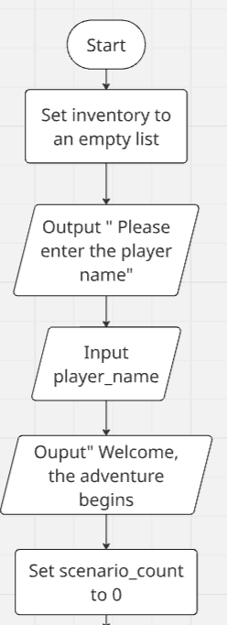

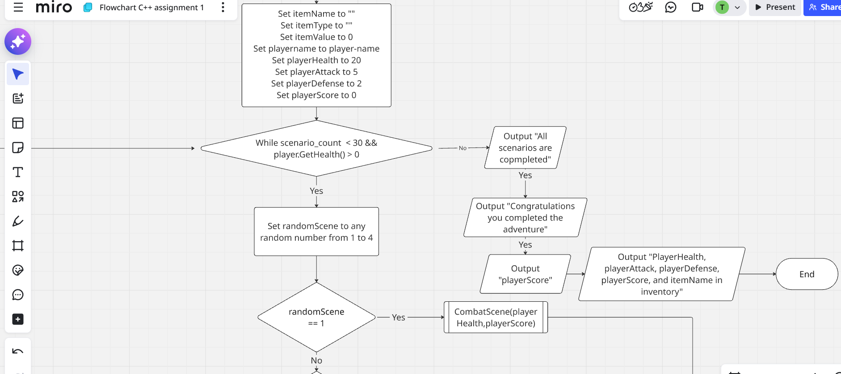

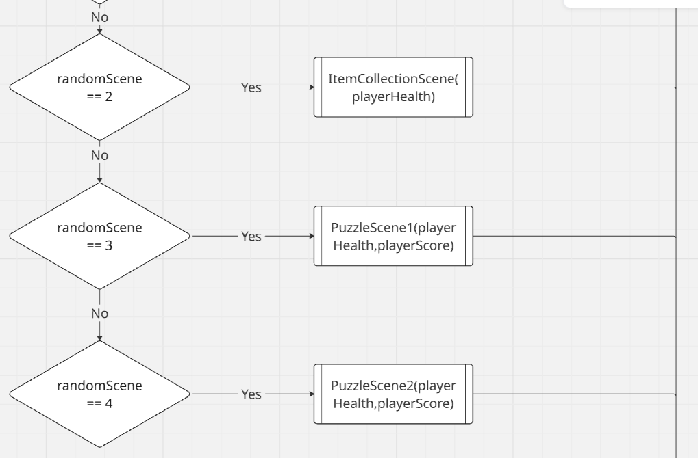

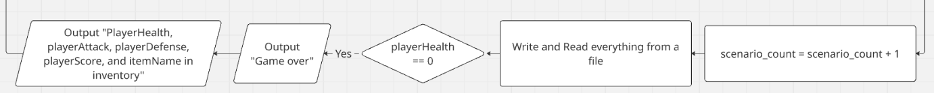

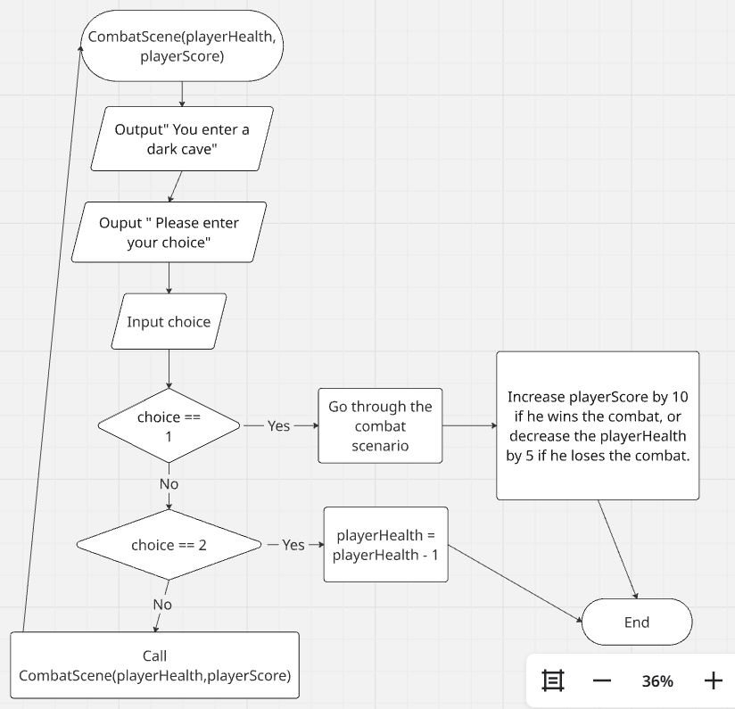

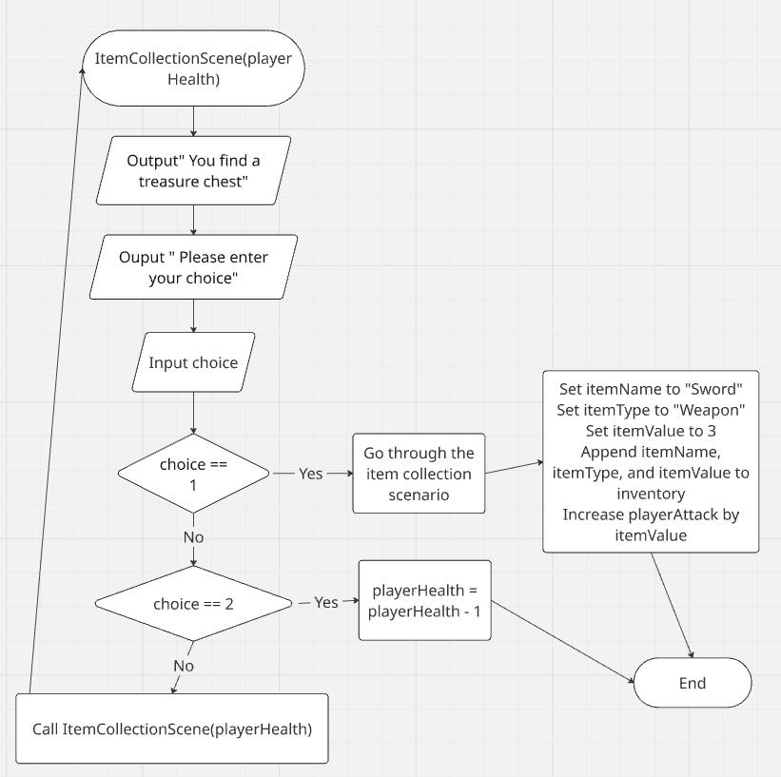
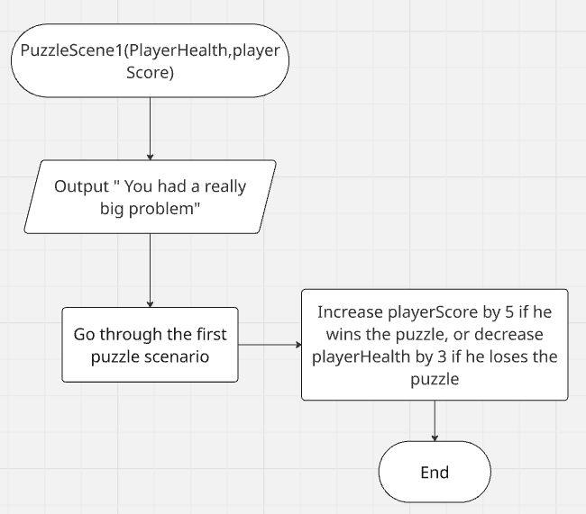

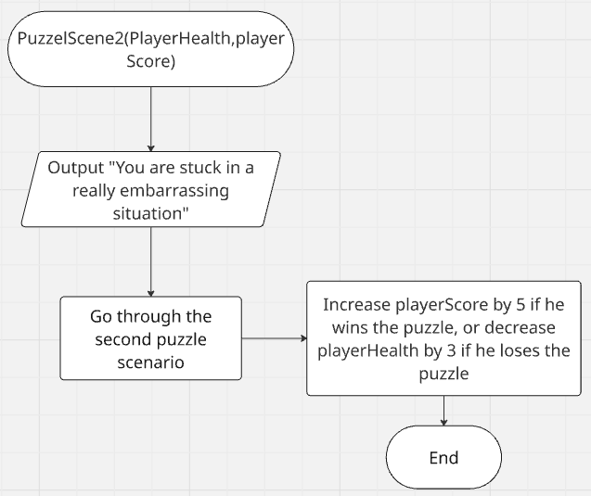

The class diagram:
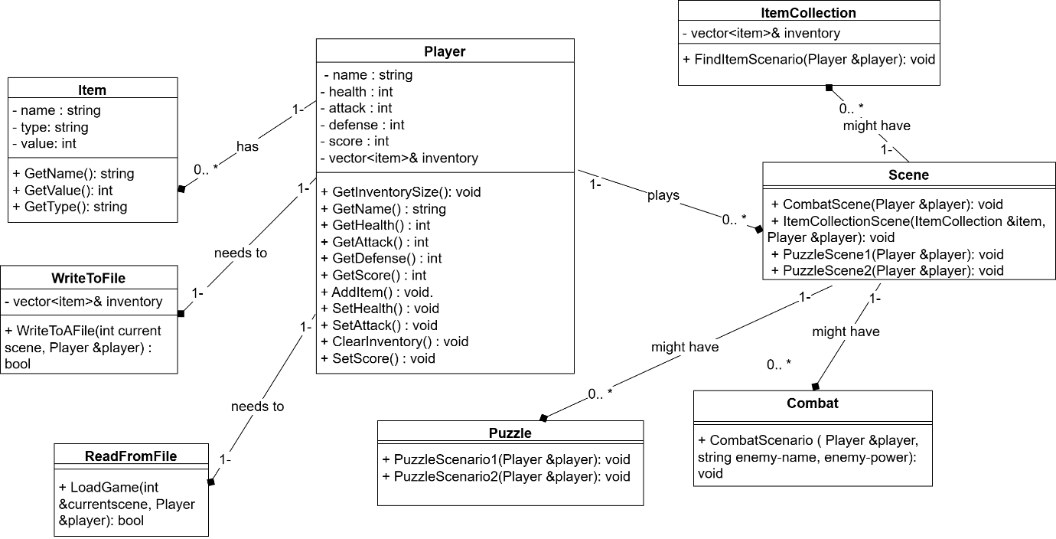

Testing:
Test number | Test | Test description | Test data | Expected output | Actual output | Comments
1 | answer | Valid test | 2- integer | Program should continue as expected. | Program continues as expected. | Test passes.
2 | answer | Invalid test | “A”  (String) | Program should respond with an error message and re-prompt. | Program responds with an error message and re-prompt. | Test passes.
3 | answer | Extreme valid test (journeyId <=100) | 100 (integer) | Program should continue as expected. | Program continues as expected. | Test passes.
4 | answer | Extreme invalid test (journeyId == "I” ) | “C”  “string” | Program should flag as an error and re-prompt. | Program flags value and asks user to re-enter. | Test passes.
5 | answer | Erroneous (string) | “D”- String | Program should flag as an error and re-prompt. | Program flags value and asks user to re-enter. | Test passes.
6 | answer | Valid test | 4- integer | Program should continue as expected. | Program continues as expected. | Test passes.
7 | answer | Invalid test | “V”  (String) | Program should respond with an error message and re-prompt. | Program responds with an error message and re-prompt. | Test passes.
8 | answer | Extreme valid test (journeyId <=100) | 200 (integer) | Program should continue as expected. | Program continues as expected. | Test passes.
9 | answer | Extreme invalid test (journeyId == "I” ) | “E”  “string” | Program should flag as an error and re-prompt. | Program flags value and asks user to re-enter | Test passes.
10 | answer | Erroneous (string) | “F”- String | Program should flag as an error and re-prompt. | Program flags value and asks user to re-enter. | Test passes.
11 | choice | Valid test | 1- integer | Program should continue as expected. | Program continues as expected. | Test passes.
12 | choice | Invalid test | “H”  (String) | Program should respond with an error message and re-prompt. | Program responds with an error message and re-prompt. | Test passes.
13 | choice | Extreme valid test (journeyId <=100) | 2 (integer) | Program should continue as expected. | Program continues as expected. | Test passes.
14 | choice | Extreme invalid test (journeyId == "I” ) | “I”  “string” | Program should flag as an error and re-prompt. | Program flags value and asks user to re-enter | Test passes.
15 | choice | Erroneous (string) | “B”- String | Program should flag as an error and re-prompt. | Program flags value and asks user to re-enter. | Test passes.
16 | choice | Valid test | 1- integer | Program should continue as expected. | Program continues as expected. | Test passes.
17 | choice | Invalid test | “H”  (String) | Program should respond with an error message and re-prompt. | Program responds with an error message and re-prompt. | Test passes.
18 | choice | Extreme valid test (journeyId <=100) | 2 (integer) | Program should continue as expected. | Program continues as expected. | Test passes.
19 | choice | Extreme invalid test (journeyId == "I” ) | “I”  “string” | Program should flag as an error and re-prompt. | Program flags value and asks user to re-enter | Test passes.
20 | choice | Erroneous (string) | “B”- String | Program should flag as an error and re-prompt. | Program flags value and asks user to re-enter. | Test passes.
21 | player_name | Valid test | “Ali” (String) | Program should continue as expected. | Program continues as expected. | Test passes.
22 | player_name | Invalid test | “”  (String) | Program should respond with an error message and re-prompt. | Program responds with an error message and re-prompt. | Test passes.
23 | player_name | Extreme valid test (length test <=14) | “Senior Citizen” | Program should continue as expected. | Program continues as expected. | Test passes.
24 | player_name | Extreme invalid test (length test >= 15) | “” | Program should respond with an error message- too long, and re-prompt. | Program responds with an error message and re-prompt. | Test passes.
25 | player_name | Error test (carriage return) | Carriage return | Program should respond with an error message and re-prompt. | Program responds with an error message and re-prompt. | Test passes.
26 | player_name | Valid test | “Ahmed” (String) | Program should continue as expected. | Program continues as expected. | Test passes.
27 | player_name | Invalid test | “”  (String) | Program should respond with an error message and re-prompt. | Program responds with an error message and re-prompt. | Test passes.
28 | player_name | Extreme valid test (length test <=14) | “Ali Mohamed” | Program should continue as expected. | Program continues as expected. | Test passes.
29 | player_name | Extreme invalid test (length test >= 15) | “” | Program should respond with an error message- too long, and re-prompt. | Program responds with an error message and re-prompt. | Test passes.
30 | player_name | Error test (carriage return) | Carriage return | Program should respond with an error message and re-prompt. | Program responds with an error message and re-prompt. | Test passes.

Technical elements:
Item class: this class should be important for knowing all the items in this program with all of their details by storing them in a vector called inventory, as each item has a name, a type, and a value.
Item constructor: this constructor is important to assign the values to the item class attributes like the name, the type, and the value.
Player class: this class helps us know the player who will play the game with all his details such as his health, name, attack, defense, score. This class also includes the inventory vector that should contain some item objects that identify the items of this program.
Player constructor: this constructor is used to assign values to all the player attributes and to add item objects to the inventory.
GetInventorySize(): this is a method in the Player class that is used to return the inventory vector size.
GetName(): this is a method in the Player class that is used to return the name of the player.
GetHealth(): this is a method in the Player class that is used to return the health of the player.
GetAttack(): This is a method in the Player class that is used to return the attack of the player.
GetDefense(): This is a method in the Player class that is used to return the defense of the player.
GetScore(): This is a method in the Player class that is used to return the score of the player.
AddItem (Item item): This is a method in the Player class that adds an item object to the inventory vector.
ClearInventory (): This is a method in the Player that clears the inventory vector by clearing all of the item objects from it.
SetAttack (int attack): This is a method in the Player class that sets the attack of the player by another value.
SetScore (int score): This is a method in the Player class that sets the score of the player by another value.
SetHealth (int health): This is a method in the Player class that sets the health of the player by another value.
ShowStats(): This is a method in the Player class that shows all the stats of the player class by showing the values of all the player attributes.
WriteToFile class: This is a class that helps us to write all the details of the player who is playing the game using the player class object that refers to the player class that has the attributes of that player which identify all the details of that player to a text file. This class also writes all the items with all their details which are the values of their attributes in the inventory vector which is in the main code to a text file.
writeToAFile(int currentscene, Player &player): This is a method in the WriteToFile class that writes all the details of the player who is playing the game. It does that using the player class object that has all the attributes of the player that identify all the details of that player to a text cin.ifile. Additionally, it also writes all the items with all their details which are the attribute values in the inventory vector which is in the main code to a text file.
ReadFromFile class: This is a class that helps us to read from a text file all the details of the player who is playing the game. It also helps us to read all the details of all the items in the inventory vector by knowing all the values of all the attributes of each item in this vector that is in the main code from a text file.
loadGame(int &currentscene, Player &player): This is a method in the ReadFromFile class that helps in reading all the details of the player who is playing the game from a text file. In addition, this method helps us to read all the details of all the items in the inventory vector that is in the main code from a text file.
ItemCollection class: This class handles the item collection scenario by adding an item to the main code's inventory vector. It also adds the item's value to the player's attack, which means the player attacked to collect the item.
ItemCollection constructor: This is a constructor in C++ that is used to add some item objects to the main code’s inventory vector.
FindItemScenario (Player &player): This is a method in the ItemCollection class that helps us to find an item to collect and increase the player attack by its value.
Combat class: This class handles the combat scenario by making the player run through a combat. So, his attack and the enemy’s attack that he is starting the combat with will increase by a random value. This means that the one who has a bigger attack wins the game so either the player or the enemy might win the combat.
CombatScenario (Player &player, string enemy_name, int enemy_power): This is a method in the Combat class that helps in handling the combat that is started between a player and an enemy. In this combat, there should be 1 winner, and this winner can be either the player or the enemy, and this winner must have a bigger attack.
Puzzle class: This class does the purpose of the puzzle scenario, as it has 2 puzzles. Any player could win any puzzle of them if he solved it correctly.
PuzzleScenario1(Player &player): This a method in the Puzzle class that displays the first puzzle that the player should solve correctly to win it. Additionally, if the player wins this puzzle, his score will be increased by 5, but if he loses the puzzle, his health will be decreased by 3.
PuzzleScenario2(Player &player): This a method in the Puzzle class that displays the second puzzle that the player should solve correctly to win it. Additionally, if the player wins this puzzle, his score will be increased by 5, but if he loses the puzzle, his health will be decreased by 3.
Scene class: This class has all of the scenes that the player might go through. Each scene in this class runs a specific scenario from the scenarios that the game has like the item collection scenario and the combat scenario.
CombatScene(Player &player): This is a method in the Scene class that has 2 choices. The first choice is going through the combat scenario and seeing who wins the combat and this person can be the player or the enemy. The second choice is that the player got bitten by leaches which means his health decreased by 1. Additionally, the user can choose any choice of them in this scene.
ItemCollectionScene(ItemCollection &item, Player &player): This is a method in the Scene class that has 2 choices. The first choice is going through the item collection scenario, and in this scenario the player finds an item and adds its value to his attack. The second choice is that the player walked past the chest, and his health decreased by 1.
PuzzleScene1(Player &player): This is a method in the Scene class that handles puzzle scenario 1, and the player might win or lose the puzzle as well.
PuzzleScene2(Player &player): This is a method in the Scene class that handles puzzle scenario 2, and the player might win or lose the puzzle as well.

Evaluation:
Firstly, I believe that my program that I did for this text-based adventure game is very effective and perfect. I am saying that because I have met all the requirements that are needed for implementing this app, as I included all of the scenario’s types that the game needs in my program. Therefore, the scenario types that I used to ensure that the game runs smoothly are the combat-based, puzzle-based, and item collection scenarios. In the combat-based scenarios, a battle or a combat is fought between a player and an enemy, and there is only one winner in it. The person who wins the battle should attack more than the other, and this person might be the player or the enemy. In addition, if the player wins the battle, his score will increase in the game by ten, but if he loses the battle, his health will be decreased by five. In the puzzle-based scenario, there are some math-based challenges, and the player has to solve the math problem of the puzzle to win the challenge. If the player wins the puzzle, his score will be increased by five, but if he loses the puzzle, his health will be decreased by 3. In the item collection scenario, the player finds an item and adds its value to his attack.
The strengths of my program are that it is very effective, and my program code uses object-oriented programming by decomposing the program into multiple classes. Each class in my program has just one responsibility, which means that it has just one purpose, like identifying the player who plays the game. Each method has one purpose, good se, as all the classes and methods in my code follow SRP, which is a good programming practice. The program has thirty scenes to go through, and each scene runs a specific scenario. There are four scenes in my program in the Scene class. Each one of the scenes runs a specific scenario, like the puzzle scenario. In addition, the program has one combat scenario, one item collection scenario, and two puzzle scenarios, and both of them are math-based. The user goes through the scenes randomly using a variable whose value is randomised between one and four, and each value runs a specific scene using an if condition. Moreover, there is a while loop that has this variable, which is randomized between one and four, and its purpose is to make the game thirty scenes by a variable named scenario_count. This variable is an integer and set to zero at first, but is incremented in each iteration in the while loop until the while loop ends when it becomes thirty or the player's health becomes zero. The program also has robust error handling for all of the variables.
The weaknesses of the program are that it does not have some object-oriented programming principles, like inheritance between classes and polymorphism. Polymorphism means a parent class that has a vector, and we can add to it objects from all of the child classes that inherit from this parent class. The program could have had more puzzle-based, combat-based scenarios of different types, other than the ones that are in the program. The program does not use many files to store the game stats, including the player name, player score, and the inventory’s items with all of their details, like the item name, item type, and item value. I could not make the program do that, and I just made the program save and load these game stats using one file because it is hard to do that using multiple files. The program has another weakness, which is that it cannot save all of the progress and resume the game at the player’s convenience. This happens because the program overwrites all of the game stats each time it runs with the new game stats without appending these stats to the old ones. The player cannot resume the game at their convenience, as the game cannot be resumed in the middle of the action of running the program. I need to handle all of these weaknesses if I want to improve my program.
There are many areas of improvement that the program can go through to make the best adventure game ever. One area of improvement is that the program needs to have a variety of items to add to the item collection scenario, not just one, as my program has, and each item needs to have a value by which the player's attack is increased. Another area of improvement is that the player should collect these varied items to improve their defense or any other special ability. The program also ensures that items have a meaningful impact that influences the gameplay by modifying any of the player attributes, not just the player attack, as the program does for the player health and the player defense. The items that the player collects should differ between weapons, clothes, and food. Each item of these should just have 1 purpose. For example, the weapons increase the player's attack, and the food just restores health, which means it does not modify any of the player's attributes. Another area of improvement is that the program needs to have some puzzle-based scenarios that use riddles or anagrams, not just math-based challenges, as the program currently has. In conclusion, I think that these are all of the areas of improvement that the program should handle to make this adventure game the best creative adventure game ever.
Through implementing the program code for this text-based adventure game, I learnt many lessons, such as the importance of the object-oriented programming principles to structure much more complicated programs. These principles are like creating meaningful classes, constructs to assign values to the attributes of these classes, and methods inside the classes. These classes are like the player class and the item class. After implementing that program, which is built on the object-oriented programming code, I realized that using procedural code for the game would be worse. This is because if I did this program using a procedural programming code, it would be harder to identify which player played the game. It will be hard to know the item or items that the player collects in the game using procedural code as well. Furthermore, I learned that the user experience is quintessential to help us know if the game is creative or not. This user experience can be the best if the program has clear layouts, instructions, and feedback, which is essential to ensure that the program is easy to use. The last thing that I have learnt after implementing that program is testing, as testing is very important to be done for all of the variables that are inputted by the user. Testing is important for that, as it ensures that invalid data that might be entered by the user for any variable is handled correctly. This happens by printing meaningful error messages and making the user input these variables again using a while loop that ends when the user inputs valid data into a specific variable. In conclusion, testing a program is important to ensure that the program behaves correctly in any case.

References:
ChatGPT. (2026). Some help with this text-based adventure game. OpenAI. prompt: Please help me with the Combat-based scenario and with passing a list between classes in this text-based adventure game.

Appendix code listing:
The program code:
#include <iostream>
#include <vector>
#include <string>
#include <cstdlib> // for rand().
#include <ctime> // for seeding rand.
#include <fstream>
#include <limits>
#include <sstream>
using namespace std;
// Item class
class Item {
private:
string name;
string type; // weapon, armor, food.
int value;
public:
string GetName() {
return name;
}
string GetType() {
return type;
}
int GetValue() {
return value;
}
Item(string n, string t, int v) {
name = n;
type = t;
value = v;
}
};
// Player class
class Player {
private:
string name;
int health;
int attack;
int defense;
int score;
(ChatGPT,2026)
vector<Item>& inventory;
public:
// A function to pass a vector to this class
Player(vector<Item>& item, string n): inventory(item) {
name = n;
health = 20;
attack = 5;
defense = 2;
score = 0;
}
int GetInventorySize() {
return inventory.size();
}
string GetName() {
return name;
}
int GetHealth() {
return health;
}
int GetAttack() {
return attack;
}
int GetDefense() {
return defense;
}
int GetScore() {
return score;
}
void AddItem(Item item){
inventory.push_back(item);
}
void ClearInventory(){
inventory.clear();
}
void SetAttack(int attack){
this->attack = attack;
}
void SetScore(int score){
this->score = score;
}void SetHealth(int health){
this->health = health;
}
// A function that shows the stats of the player class
void ShowStats() {
cout << "\n--- " << name << "'s Stats ---\n";
cout << "Health: " << health << endl;
cout << "Attack: " << attack << endl;
cout << "Defense: " <<defense << endl;
cout << "Score: " << score << endl;
cout << "Inventory: ";
if (inventory.empty()) cout << "None";
for (Item item : inventory) cout << item.GetName() << " ";
cout << "\n--------------------\n";
}
};
// A class that writes to a file
class WriteToFile{
private:
vector<Item>& inventory;
public:
// A function to pass a vector to this class
WriteToFile(vector<Item>& item): inventory(item) {}
// Writing to a file.
bool WriteToAFile(int currentscene, Player &player) {
fstream fs("savegame.txt", ios::out);
if (!fs.is_open())
{
cout << "Error: Could not open save file.\n";
return false;
}
string name = player.GetName();
int health = player.GetHealth();
int attack = player.GetAttack();
int defense = player.GetDefense();
int score = player.GetScore();
int inventorysize = player.GetInventorySize();
// Write player information
fs << name << endl;
fs << health << endl;
fs << attack << endl;
fs << defense << endl;
fs << score << endl;
// Write current scene
fs << currentscene << endl;
// Write inventory size.
fs << inventorysize << endl;
// Write items
for ( Item item : inventory)
{
fs << item.GetName() << ","
<< item.GetType() << ","
<< item.GetValue() << endl;
}
if (fs.fail())
{
cout << "Error: Failed while writing save file.\n";
return false;
}
fs.close();
return true;
}
};
// A class that reads from a file
class ReadFromFile{
public:
// Reading from a file.
bool LoadGame(int &currentscene,Player &player) {
ifstream fs("savegame.txt");
if (!fs.is_open())
{
cout << "Error: Save file not found.\n";
return false;
}
string name = player.GetName();
int health = player.GetHealth();
int attack = player.GetAttack();
int defense = player.GetDefense();
int score = player.GetScore();
int inventorysize = player.GetInventorySize();
getline(fs,name);
// Read player data
if (!(fs >> health >> attack >> defense >> score >> currentscene))
{
cout << "Error: Save file corrupted.\n";
return false;
}
// Read inventory size
if (!(fs >> inventorysize))
{
cout << "Error reading inventory size.\n";
return false;
}
player.ClearInventory();
string line;
getline(fs, line); // clear newline
string itemname, itemtype;
string valuestr;
for (int i = 0; i < inventorysize; i++)
{
if (!getline(fs, line))
{
cout << "Error reading inventory item.\n";
return false;
}
stringstream ss(line);
if (!getline(ss, itemname, ',') ||
!getline(ss, itemtype, ',') ||
!getline(ss, valuestr, ','))
{
cout << "Error parsing inventory item.\n";
return false;
}
int value = stoi(valuestr);
player.AddItem(Item(itemname, itemtype, value));
}
fs.close();
cout << "Game loaded successfully!\n";
return true;
}
};
// A class the does the item collection scenario.
class ItemCollection{
private:
vector<Item>& inventory;
public:
// A function to pass a vector to this class
ItemCollection(vector<Item>& item): inventory(item) {}
// Function to add an item.
void FindItemScenario(Player &player) {
cout << "\nYou found a sword!\n";
bool hassword = false;
for (Item item : inventory) {
if (item.GetName() == "Sword") {
hassword = true;
}
}
Item sword("Sword", "weapon", 3);
if (!hassword) {
inventory.push_back(sword);
}
else{
int attack = player.GetAttack();
attack += sword.GetValue();
player.SetAttack(attack);
cout << "Your attack increased by " << sword.GetValue() << "!\n";
}
}
};
// Combat scenario class.
class Combat{
public:
// Combat function
(ChatGPT,2026)
void CombatScenario(Player &player, string enemy_name, int enemy_power) {
cout << "\nCombat! " << enemy_name << " appears!\n";
int playerroll = player.GetAttack() + (rand() % 6 + 1);
int enemyroll = enemy_power + (rand() % 6 + 1);
cout << "Your combat score: " << playerroll << endl;
cout << enemy_name << "'s combat score: " << enemyroll << endl;
int score = player.GetScore();
int health = player.GetHealth();
if (playerroll >= enemyroll) {
cout << "You defeated the " << enemy_name << "!\n";
score += 10;
player.SetScore(score);
} else {
cout << "You were injured by the " << enemy_name << "!\n";
health -= 5;
player.SetHealth(health);
}
}
};
// Puzzle scenario class.
class Puzzle{
public:
// Puzzle function.
// Puzzle 1.
void PuzzleScenario1(Player &player) {
cout << "\nPuzzle Time!\n";
cout << "What is 7 + 5? ";
int answer;
while (!(cin >> answer)) {
cout << "Invalid input!\n";
cout << "Please enter a valid input: \n";
cin.clear();
cin.ignore(numeric_limits<streamsize>::max(), '\n');
}
cin.ignore(numeric_limits<streamsize>::max(), '\n');
int score = player.GetScore();
int health = player.GetHealth();
if (answer == 12) {
cout << "Correct! You gain 5 points.\n";
score += 5;
player.SetScore(score);
} else {
cout << "Wrong! You lose 3 health.\n";
health -= 3;
player.SetHealth(health);
}
}
// Puzzle 2.
void PuzzleScenario2(Player &player) {
cout << "\nPuzzle Time!\n";
cout << "What is 12 + 20? ";
int answer;
while (!(cin >> answer)) {
cout << "Invalid input!\n";
cout << "Please enter a valid input: \n";
cin.clear();
cin.ignore(numeric_limits<streamsize>::max(), '\n');
}
cin.ignore(numeric_limits<streamsize>::max(), '\n');
int score = player.GetScore();
int health = player.GetHealth();
if (answer == 32) {
cout << "Correct! You gain 5 points.\n";
score += 5;
player.SetScore(score);
} else {
cout << "Wrong! You lose 3 health.\n";
health -= 3;
player.SetHealth(health);
}
}
};
// Scene class.
class Scene{
public:
// Scenes functions.
// Combat scene.
void CombatScene(Player &player) {
cout << "\nCombat Scene: You enter a dark cave.\n";
cout << "1) Cross the rickety bridge\n";
cout << "2) Swim in the shallow pool\n";
int choice;
while (!(cin >> choice)) {
cout << "Invalid input!\n";
cout << "Please enter a valid input: \n";
cin.clear();
cin.ignore(numeric_limits<streamsize>::max(), '\n');
}
cin.ignore(numeric_limits<streamsize>::max(), '\n');
int health = player.GetHealth();
Combat combat = Combat();
if (choice == 1) {
combat.CombatScenario(player, "Cave Troll", 8);
} else if (choice == 2) {
cout << "You get bitten by leeches! Lose 1 health.\n";
health -= 1;
player.SetHealth(health);
} else {
cout << "Invalid choice. Try again.\n";
return CombatScene(player);
}
}
// Item collection scene.
void ItemCollectionScene(ItemCollection &item, Player &player) {
cout << "\nItem Collection scene: You find a treasure chest.\n";
cout << "1) Open it\n";
cout << "2) Ignore it\n";
int choice;
while (!(cin >> choice)) {
cout << "Invalid input!\n";
cout << "Please enter a valid input: \n";
cin.clear();
cin.ignore(numeric_limits<streamsize>::max(), '\n');
}
cin.ignore(numeric_limits<streamsize>::max(), '\n');
int health = player.GetHealth();
if (choice == 1) {
item.FindItemScenario(player);
} else if (choice == 2) {
cout << "You walk past the chest.\n";
health -= 1;
player.SetHealth(health);
} else {
cout << "Invalid choice. Try again.\n";
return ItemCollectionScene(item,player);
}
}
// Puzzle scene 1.
void PuzzleScene1(Player &player) {
cout << "\nPuzzle scene 1: You had a really big problem.\n";
Puzzle puzzle = Puzzle();
puzzle.PuzzleScenario1(player);
}
// puzzle scene 2.
void PuzzleScene2(Player &player) {
cout << "\nPuzzle scene 2: You are stuck in a really embarrassing situation .\n";
Puzzle puzzle = Puzzle();
puzzle.PuzzleScenario2(player);
}
};
// Main game loop.
int main() {
srand(time(0));
vector<Item> inventory;
cout << "Enter your player name: ";
string player_name;
while (!getline(cin, player_name)) {
cout << "Input error. Try again.\n";
cout << "Please enter a valid input: ";
cin.clear();
cin.ignore(numeric_limits<streamsize>::max(), '\n');
}
while (player_name.empty()) {
cout << "Name cannot be empty. Enter your name: ";
getline(cin, player_name);
}
Player player(inventory,player_name);
ItemCollection item(inventory);
ReadFromFile read_from_file;
WriteToFile write_to_file(inventory);
Scene scene = Scene();
cout << "\nWelcome, " << player.GetName() << "! Your adventure begins!\n";
int scenario_count = 0;
// Game has 30 scenarios to call.
while (scenario_count < 30 && player.GetHealth() > 0) {
int random_scene = rand() % 4 + 1;
if (random_scene == 1) {
scene.CombatScene(player);
}
else if (random_scene == 2) {
scene.ItemCollectionScene(item,player);
}
else if (random_scene == 3) {
scene.PuzzleScene1(player);
}
else if (random_scene == 4) {
scene.PuzzleScene2(player);
}
scenario_count++;
write_to_file.WriteToAFile(scenario_count,player);
read_from_file.LoadGame(scenario_count,player);
if (player.GetHealth() <= 0) {
cout << "\nYou have no health left.\n";
cout << "Game Over!\n";
player.ShowStats();
return 0;
}
}
cout << "\nScenario " << scenario_count << " completed!\n";
cout << "\nCongratulations! You completed the adventure.\n";
cout << "Final Score: " << player.GetScore() << endl;
player.ShowStats();
return 0;
}

